**1.Writing code on eclipse Ide**

package L4;

import java.util.ArrayList;

import java.util.Arrays;

import java.util.Scanner;

public class LIS {

static int lis(int arr[], int n)

{

int lis[] = new int[n];

int i, j, max = 0;

for (i = 0; i < n; i++) {

lis[i] = 1;

}

System.out.println(Arrays.toString(lis));

for (i = 1; i < n; i++) {

for (j = 0; j < i; j++) {

if (arr[i] > arr[j] && lis[i] < lis[j] + 1) {

lis[i] = lis[j] + 1;

}

}

}

for (i = 0; i < n; i++) {

if (max < lis[i]) {

max = lis[i];

}

}

return max;

}

public static void main(String[] args) {

Scanner sc = new Scanner(System.in);

System.out.println("enter the number of elements in list (number < 100) :");

int i = sc.nextInt();

int [] arrlist = new int[i];

for(int m=0;m<i;m++) {

System.out.print("Enter the element "+(m+1)+" :");

int num =sc.nextInt();

arrlist[m]=num;

}

System.out.println();

System.out.println("your list with "+i+" elements :");

System.out.println(Arrays.toString(arrlist));

System.out.println("the longest increasing subsequence is "+lis(arrlist,i));

}

}

**2. Executing output**

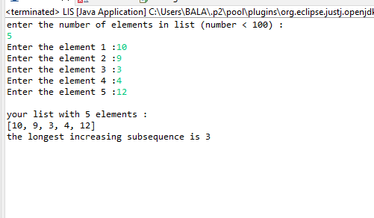

**3.Pushing in Git Hub**